Telecom Customer Churn Analysis

Amruta Mankawde , Ketan Gangwal

Vishwakarma Institute of Technology Pune , Maharashtra , India

***Abstract* — *With the ongoing development in the telecom industry, the service providers are encouraged to expand their subscriber network. To meet this need of survival, retention of the existing customers has become critical. By studies conducted in the Telecom Industry, it is found that the cost of acquiring a new customer is more than retaining the existing one. The proposed system is a machine learning model that predicts from the given dataset, whether the customer is likely to churn or not. It also predicts whether a new joining customer is likely to churn or not. Hence, can be used for both the new arriving as well as existing customers.***

***Keywords— Telecom industry, customer, churn, prediction, machine learning.***

# **INTRODUCTION**

Due to growth and advancement in Information Technology, a large amount of data is available. This data and its exchange has led to increase in competition between the telecom companies. Hence, the companies are more inclined to retain the clients with them. In the studies conducted, it is concluded that acquiring new customers is more costly than retaining the existing ones. Hence, it has become a crucial factor for companies to retain the existing customers for their survival. Hence, different tools are being developed for retaining the customer in different industries for retaining their existing customers.

The purpose of this system is creating a model that will be able to predict whether the customer is likely to churn or not. The prediction will be done from the dataset provided to the model. The system can also predict whether a new arriving customer in the company will churn or not. The system uses a machine learning model for this kind of prediction.

1. **LITERATURE REVIEW**

[1] In Customer Churn Analysis in Telecom Industry, 2015, the authors in this paper suggest that the Companies usually have a greater focus on customer acquisition and keep retention as a secondary priority. However, it costs five times more to attract a new customer than it costs to retain the existing one. Increasing customer retention rates by 5% can increase profits by 25% to 95%, according to research done by Bain & Company.

[2] In Predictive analysis of customer churn in telecom industry using supervised learning, 2020 by Shreyas Rajesh Labhsetwar, The research focuses on implementing machine learning (ML) algorithms to identify potential churn customers, categorize them based upon usage patterns, and visualize the analysis results.

[3] In a Prediction Model of Customer Churn considering Customer in 2021 by Ming Zhao, Jiafu Su, the authors analyze the trends and causes of customer churn through data mining algorithms and gives the answers to such questions as how the customer churn occurs, the influencing factors of customer churn, and how enterprises win back churned customers.

[4] Tomas Philip Rúnarsson, Ólafur Magnússon, Birgis Hrafnkelsson developed a churn prediction model that is able to output the probabilities that customers will churn or not in the near future. In this paper the training data is used to build classifiers by using machine learning methods.

[5] N.Kamalraj and A.Malathi focussed their research on the better understanding of churn prediction using data Data Understanding Data preparation Data Modeling Business Deployment Evaluation Understanding DATA mining techniques. Telecommunication industry can use this approach to customer retention activities within the context of their Customer Relationship Management efforts. The author uses the DM technique on customer details.

1. **METHODOLOGY**

Here to predict the customer churn, we took a dataset for analysis. We perform EDA on the dataset. EDA is the process of analyzing the data using visual techniques.

In model building, we used a decision tree classifier which gave us the accuracy of 0.93 for the prediction. However, the precision was low. Then after using the random forest classifier, the accuracy was 0.931 and there was an appreciable increase in the precision as well. After the model building, we created a web application taking different values as 0 or 1 and predicting whether the customer will churn or not.

# **Result and Discussion**

The churn rate, which is also known as the rate of customer churn, is the rate at which customers stop doing business with a company. For knowing this rate or in other words, predicting whether a customer is likely to churn or not, we have developed a machine learning model that can predict whether the customer is likely to churn or not. The model is also capable of predicting whether a new arriving customer will churn or not.

The development of the model starts with the EDA analysis of the dataset which we have collected.

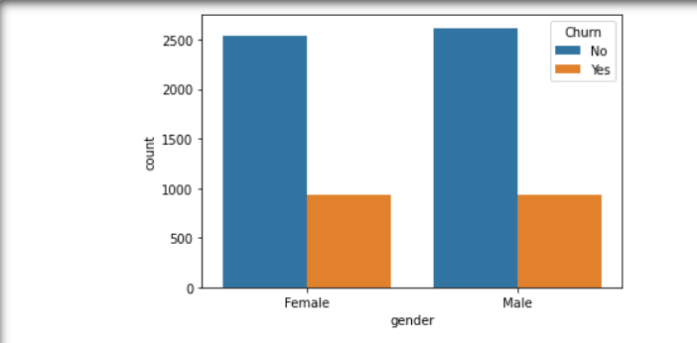

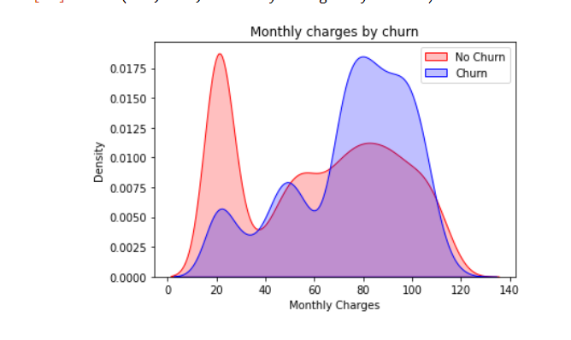

EDA Analysis

On this EDA analysis we are ready with a dataset that can be used to predict whether the customer is likely to churn.

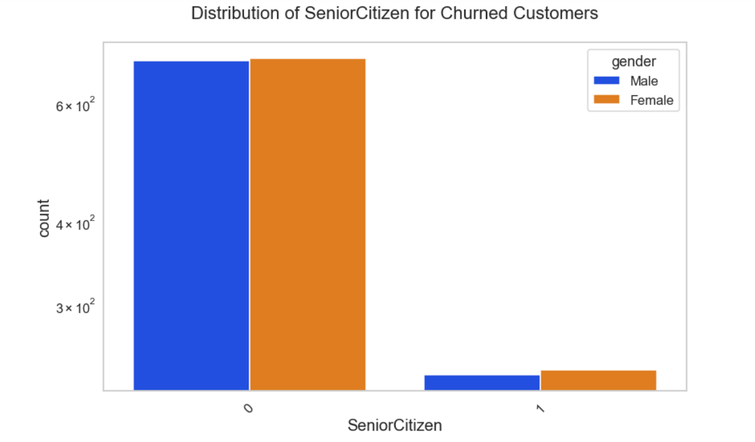

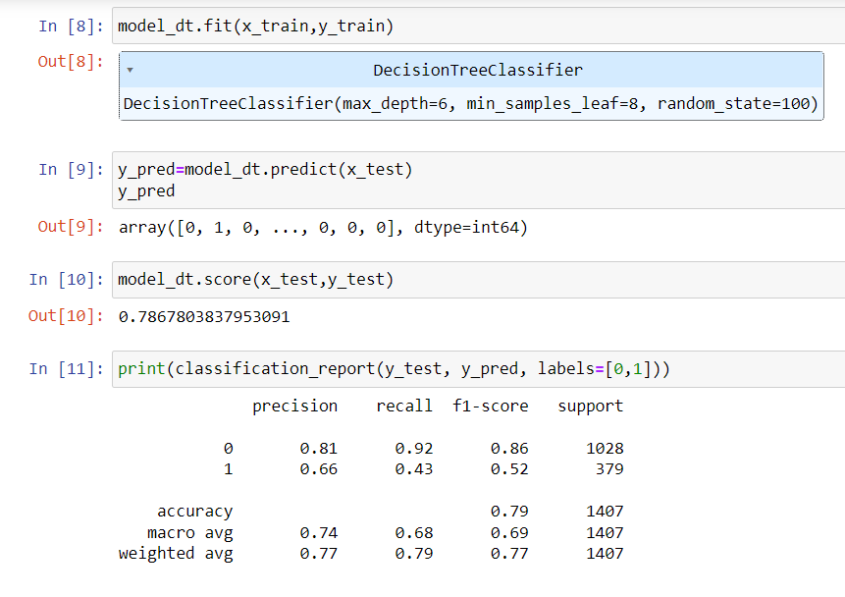

This model is used to predict that the customer will churn or not. Hence, using this model in the telecom company, the company is able to know about the relationship between the company and the customer and take actions accordingly to retain the customer.

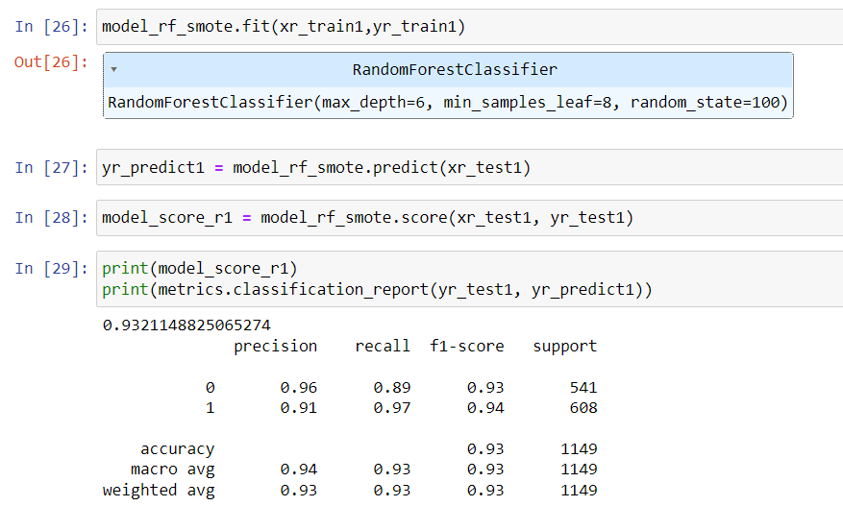

Deployment using Flask -

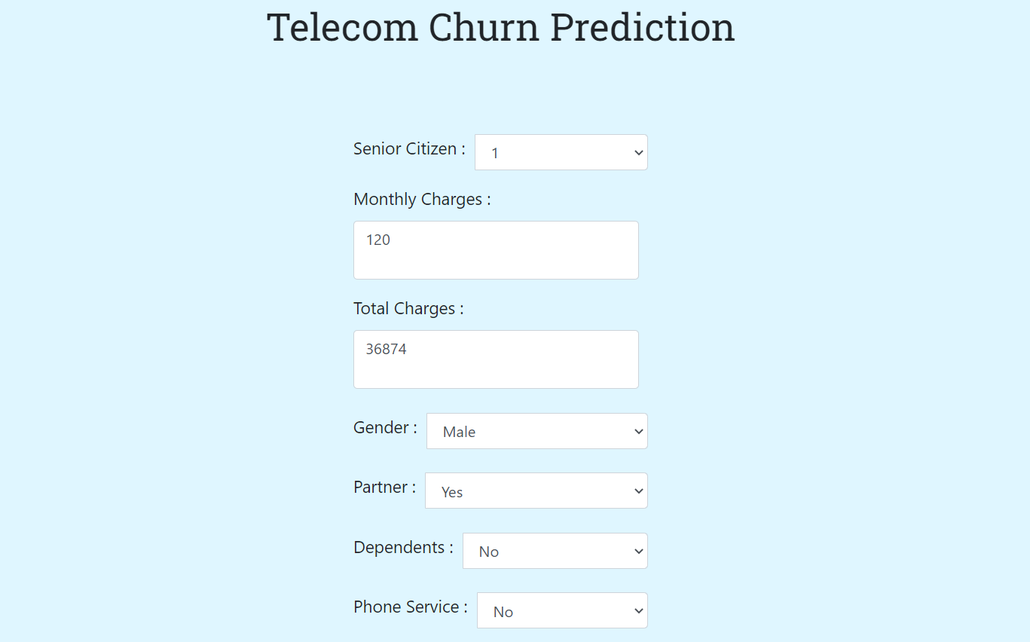

The user has to give the inputs of the parameters that are shown in the image above.

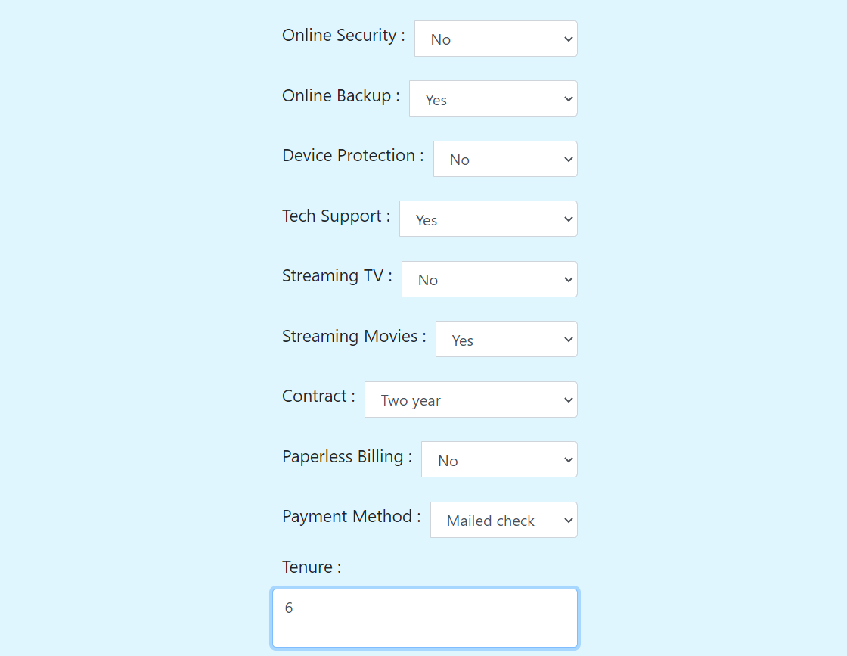

Also, a drop down menu is created for all the attributes except Monthly Charges , Total Charges and Tenure.

The Customer will churn or not will be displayed in the Text Area as shown below -

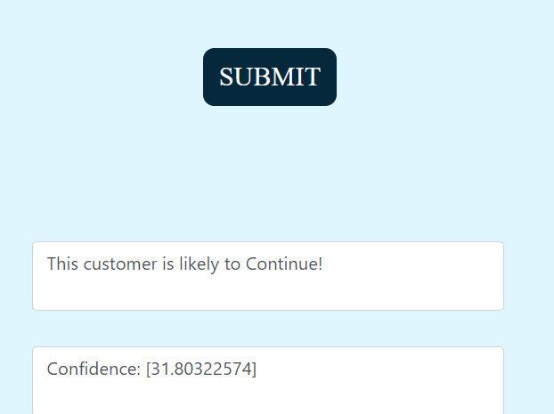

The above image is of the web application that is used to predict the telecom churn from a given data. After entering valid values in the above attributes, the application predicts the telecom churn by using the model that we have developed in the back end. At the end, we will know whether the customer will churn or not from the company.

# **Conclusion**

The telecom industry has suffered from both high churn rates and immense churning loss. However, the business loss can be managed by keeping the customer churn at an acceptable level. In this paper, we discussed how we created a prediction model that can predict the customer churn. By knowing about the customer churn, the company can take actions to retain the customers.

**REFERENCES**

[1] Kiran Dahiya, Surbhi Bhatia,Customer Churn Analysis in Telecom Industry, 2015,Shreyas Rajesh Labhsetwar, Predictive analysis of customer churn in telecom industry using supervised learning, 2020.

[2] Ming Zhao , Jiafu Su, A Prediction Model of Customer Churn considering Customer, 2021

[3] Shreyas Rajesh Labhsetwar, Predictive analysis of customer churn in telecom industry using supervised learning, 2020

[4] Shin-Yuan Hung , David C. Yen , H. Wang, Applying data mining to telecom, Expert Systems with Applications 31 (2006) 515–524, Elseiver.

[5] V. Umaparvathi, K. Iyakutti, Applications of Data Mining Techniques in Telecom Churn Prediction, International Journal of Computer Applications (0975 – 8887) Volume 42– No.20, March 2012.